Fifa 2010
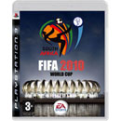14,90 €
Τα ηλεκτρονικά παιχνίδια και οι κονσόλες

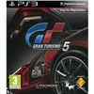
  096337
  Sony Gran Turismo 5
  29,00 €
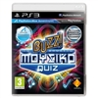
  095972
  Sony Buzz Το Απόλυτο Μουσικό Κουίζ
  32,80 €

  103280
  Konami Pro Evolution Soccer 2012
  55,90 €


  104346
  EA Fifa 2012
  59,90 €
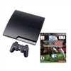
  103283
  Sony Console PS3 & Pro Soccer 2012
  289,00 €
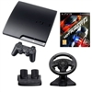
  104329
  Sony Console PS3 160GB & NFS Hot Pursuit & Racing Wheel
  299,00 €
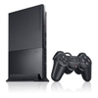
  071511
  Sony Console Playstation 2 Black Slim New
  !
  93,65 €
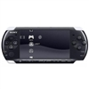
  081376
  Sony Console PSP 3000
  134,00 €

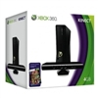
  096125
  299,00 €
Microsoft Console Xbox 360 4GB & Kinect
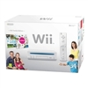
  105469
  Nintendo Console Wii & Party & Sports
  149,00 €
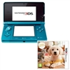
  101097
  Nintendo Console 3DS Blue & Golden Retriever
  .
  219,00 €

